Step-by-Step Guide to Building Your LinkedIn Profile

**Why is your LinkedIn Profile Important?**

Pay as much attention to your LinkedIn Profile as you do to your resume and other materials. A strong LinkedIn Profile will lead to more positive responses when you ask to meet with people and will also help companies trying to differentiate between applicants. Recruiters often use LinkedIn to find qualified candidates, so the more robust your profile, the more likely recruiters will find you.

Your LinkedIn profile will use much of the same information as you included in your resume, so no need to start from scratch. Keep your resume handy as you develop your LinkedIn profile.

Get started with the steps below!

**1. Set Up Your Basic Information**

* **Profile Photo:** Your profile photo is a representation of your brand as a professional. You should be smiling and wearing business casual clothing in the picture. You may choose to get a professional headshot, or you may already have a good picture. This picture should be used across all platforms so that companies who are looking to learn more about you recognize you.
* **Background Image:** On LinkedIn, you can replace the LinkedIn template background with a background of your own. This photo should be between 1000x425 and 4000x4000 pixels, and you can google “LinkedIn background images” for some options. Select a background image that is in line with your personal brand. This photo should be consistent with your portfolio color schemes.
* **Contact Information:** Include up-to-date contact information that allows recruiters and connections to contact you. Use a professional email address (e.g. not hotmail) and make sure you include phone numbers and email addresses that you check on a regular basis.
* **Headline:** Write a catchy headline that highlights your background and encourages employers to review your profile. Include positive qualities and highlight your uniqueness in the headline.

|  |
| --- |
| **Example of Headline:** Experienced Data professional with expertise turning numbers into results. |

* **Summary:** Your summary should be based on your professional brand statement. Just as you did for your resume, take that statement, and adapt it for LinkedIn. You may want to add a bit more of your “voice” for your LinkedIn summary than you did for your resume as this summary provides a more detailed story of you and your life/career progression.

**2. Convey Your Experience & Education**

* **Experience:** The experience section should present your employment in an easy-to-follow way. Employers should be able to clearly follow your employment history (including places and dates, job titles, and skills). The titles, dates, and locations should mirror your resume precisely. If you had to cut important content from your resume to save space, you could add in this section on Linkedin.
* **Education:** Your education should first list the university programs you have successfully completed and then the degrees you have received in reverse chronological order. Again, this section should mirror your resume.

**3. Set Up Your Skills, Recommendations, Accomplishments & Interests**

* **Skills & Endorsements:** Employers want to see both technical and transferable skills. Include soft skills that you have used in previous jobs (e.g. time management, organization, problem-solving). You should have at least 20 skills. Maintaining a targeted list of skills on your profile helps you gain interest from potential employers and match you with the right opportunities. (To identify your own transferable skills, check out [this article](https://www.livecareer.com/career/advice/jobs/transferable-skills-set).)
* **Recommendations:** Employers understand your skills better when they can read positive feedback from previous supervisors, coworkers, professors, etc. Recommendations should attest to your skill set and work ethic, adding valuable information to your profile. Request recommendations from 2 - 4 (or more) of your connections. You can do that by going to the profile of your potential recommender, at the top, select More > Request Recommendation. This button sends a LinkedIn message and email to that user, and is often a more productive way to get the recommendation written than a verbal request as it sends the writer to the exact place they need to go.
* **Accomplishments:** Highlight your top 2 - 3 projects in this section, making sure the most recent accomplishments are at the top (you can click and drag if they are out of order).
* **Interests:** A strong interests section can help employers feel connected to you. List interests that demonstrate your active involvement in the industry and professional-related groups, companies, and other entities, and follow companies and/or people within your industry space. Have a minimum of 20 interests, and make sure they are varied. Chose concepts, ideas, influencers, sports teams, schools, companies, etc.

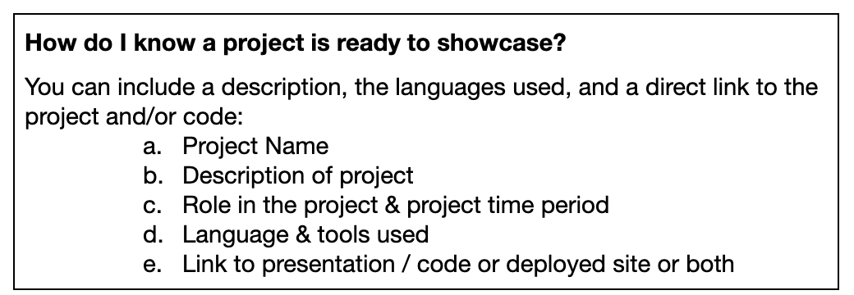

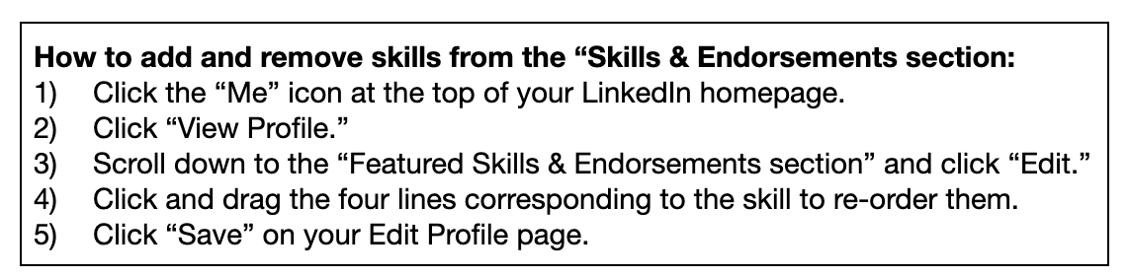

**4. Proofread**

At this point, go back and proofread your LinkedIn profile.

* Make sure spelling is accurate.
* Check for consistent punctuation.
* Check to make sure the tone is consistent throughout.
* Check to make sure all links are working.
* Ask a friend or family member to review it as well.